INFORMATION MANAGEMENT
Exercise 10
1. Display the sum of ages of employees in Bignet.
SELECT SUM(age) FROM employee_data;
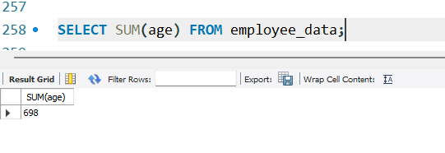

2. How would you calculate the total years of service the employees of Bignet have in the company?
SELECT SUM(yos) FROM employee_data;
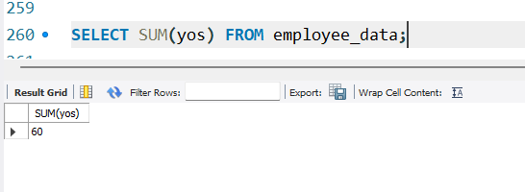

3. Calculate the sum of salaries and the average age of employees who hold CEO as their title.
SELECT SUM(salary) FROM employee_data WHERE title='CEO';
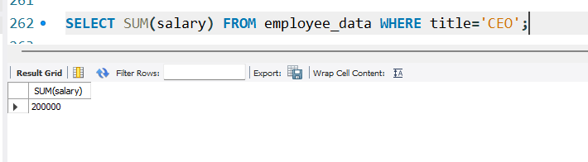
SELECT AVG(age) FROM employee_data WHERE title='CEO';
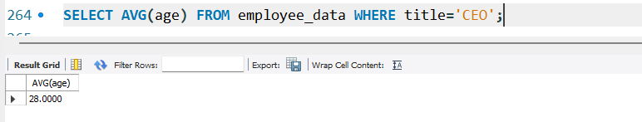

4. What do you understand from the following statement?
SELECT (SUM(perks)/SUM(salary)*100) FROM employee_data;
